**WORKSHOP 5**

**VARIABLE AND PROCEDURE AND TRIGGER IN SQL**

Cho 2 bảng R và S

R

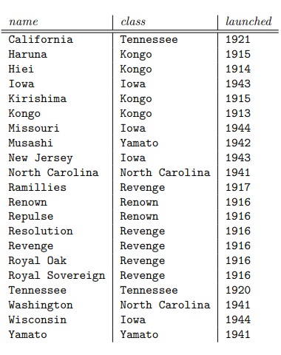

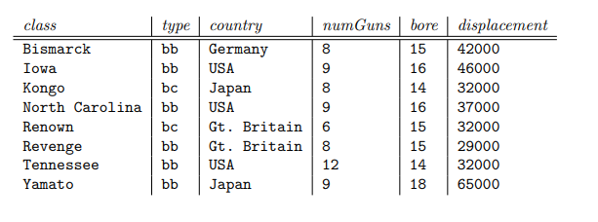S

1. **Using exercise 2 Database, write procedures that**
2. Get **name, and class** of ship that after launched year that was input by a user.

CREATE PROC proc_Get_Ship_By_Lauched (@Lauched int)

AS

BEGIN

SELECT R.name, R.class, R.lauched

FROM R

WHERE R.lauched > @Lauched

END

EXEC proc_Get_Ship_By_Lauched @Lauched = 1921

1. Search **all information of ship(s**) where the name is input by a user.

CREATE PROC proc_Get_Ship_By_Name @Name VARCHAR(50)

AS

BEGIN

SELECT *

FROM R

WHERE R.name = @Name

END

EXEC proc_Get_Ship_By_Name @Name = 'California'

1. Return **an output**, which is **the total number of ships** that were **built by the United States**.

CREATE PROC proc_Get_Total_Ship_By_Country @Country VARCHAR(50)

AS

BEGIN

SELECT S.country ,COUNT(R.class) AS TotalShip

FROM R JOIN S ON R.class = S.class

WHERE S.country = @Country

GROUP BY S.country

END

EXEC proc_Get_Total_Ship_By_Country @Country = 'USA'

1. Add a ship to table R, where all the information is input from the user.

CREATE PROC proc_Insert_Ship @Name VARCHAR(50),

@Class VARCHAR(50),

@Lauched INT

AS

BEGIN

INSERT INTO R

VALUES(@Name, @Class, @Lauched)

END

EXEC proc_Insert_Ship @Name = 'Titanic',

@Class = 'Kongo',

@Lauched = 1922

1. Update **Displacement and numguns** information of a ship in table S, where the information is input from the user.

CREATE PROC proc_Update_Ship @Class VARCHAR(50),

@Displacement INT,

@Numguns INT

AS

BEGIN

UPDATE S

SET displacement = @Displacement,

numGuns = @Numguns

WHERE class = @Class

END

EXEC proc_Update_Ship @Class = 'Yamato',

@Displacement = '70000',

@Numguns = 11

1. Create a trigger that prints all the information of the deleted ship by shipname.

CREATE TRIGGER trig_Delete_Ship

ON R

AFTER DELETE

AS

BEGIN

SELECT * FROM deleted

END

DELETE FROM R

WHERE name = 'Titanic'

1. Create a trigger that returns the total number of ship after insertion.

C1:

CREATE TRIGGER trig_Insert_Ship

ON R

AFTER INSERT

AS

BEGIN

SELECT COUNT(*) AS TotalShip

FROM R

END

INSERT INTO R

VALUES('Titanic', 'Iowa', 1922)

C2:

CREATE TRIGGER trig_Insert_Ship

ON R

AFTER INSERT

AS

BEGIN

DECLARE @TotalShip INT

SELECT @TotalShip = COUNT(*) FROM R

PRINT 'Total number of ship: ' + CAST(@TotalShip AS VARCHAR(10))

END

INSERT INTO R

VALUES('Titanic', 'Iowa', 1922)